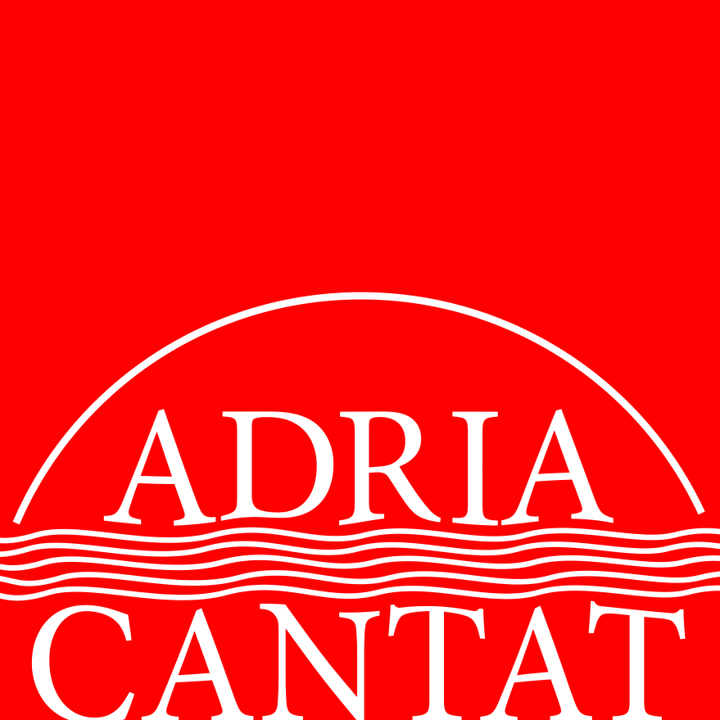

2018.

APPLICATION

Choir name
Mixed – Male - Female
Number of singers
Choir website
Town/postal code
Address
Contact person
Telephone
E-mail
Conductor/artistic director
Telephone
E-mail

 | Composer/ arranger  (full name and surname) | Composition/ Arrangement | Type of performance  Instrumental backing  (a cappella/type of instrument) | Duration
1
2
3
4

You can register 3 - 4 compositions/arrangements, together lasting all together from 8 to 10 minutes.
.
Category

Enter the code and write down the full name of the category you wish to compete in.

(small choir up to 12 singers/ big choir more than 12 singers)

Category A - National folkloristic music

A1 - small mixed choir
A4 – big mixed choir
A2 - small male choir
A5 - big male choir
A3 - small female choir
A6 - big female choir

Category B - Foreign folkloristic music

B1 - small mixed choir
B4 – big mixed choir
B2 - small male choir
B5 - big male choir
B3 - small female choir
B6 - big female choir

Every choir can compete in two categories at most. An individual application and separate application form are required for every category a choir wants to compete in.

It is necessary to send the following to apply:

via e-mail
- filled application form as a Word document or PDF file
- choir photograph in high resolution
- conductor photograph in high resolution
- choir CV, short (Word-100 words at most)
- conductor CV, short
(Word-100 words at most)
Irregular application formats and oversized CV's will not be admissible.
Photos may not be in the form of Word or PDS documents.

via post
- four copies of the scores for the registered pieces
- verification of paid registration fees

Participation Fees:
The participation fees are 150€ for single category, or 200€ for two categories. The payments are to be made out to:

HRVATSKA UDRUGA ZBOROVOĐA SWIFT: ZABA HR2X IBAN HR6023600001102023177

Bank name/address: ZAGREBAČKA BANKA, Trg bana Josipa Jelačića 10, 10000 Zagreb, Croatia

When the forms arrive, the organizer will inform the choir on whether their participation was accepted or not. Within seven days of receiving the notice the choir has to pay the application fee and send the receipt to HUZ (Croatian Choral Directors Association). The application deadline is April 19th, 2018. Please make sure all the information is correct and that all names are complete.

HUZ Croatian Choral Directors Association – Vrbik 11 – HR 10000 Zagreb, Croatia

info@choralcroatia.com

All other information is available via phone: +385-98-275961 and +385-1-6198469.

www.choralcroatia.com

